

The Book of Status

This is our story, our knowledge,
our interpretation of the world.

License: Creative Commons (CC BY-SA 4.0)
Latest: https://book.status.im
Generated: 2018.02.20 17:41 UTC
Previous Commit: b4272c2ac93e817fad0be60b0dced554dbad8103
github.com/status-im/book.status.im.git

Foundations
Contents

Past & How it all began, a Foreword from Carl & Jarrad
Status Organisational Design
Written by Jarrad October 19 2017.
Raw Document: default (exported at October 19 2017 11-50-52).svg

Purpose of this Document
Currently the design of the organisation has been done in a as-needed basis, as a result there is a lack of clarity in understanding of the organisational structure. This has resulted in confusion from sparse information, lack of focus, overwhelming contributors, encapsulation and a semi-hierarchical org chart. All of these traits are the very opposite of what Status is about.

Here I’m looking to solve 3 problems:
- Get clarity and export knowledge(documentation) in all endeavours the organisation undertakes, before we undertake them. So anyone can understand the shared vision, requirements and plan of the Idea, before and during its execution.
- Discover a way of bounding our scope to keep all endeavours bound by organisational capacity.
- Ensuring openness, transparency and permissionless participation are integral components in the organisation’s design.

With this document I am to present my view on the overall organisation and a unified framework for all subsequent organizational changes, process designs and can be used directly for many operations within the organisation.

Goals of Organisation
Although this should be described in “Vision & Goals” I believe it’s helpful to read this document with our overall goals in mind.

Status should design its goals around 3 metrics:
- Monthly Active Contributors
- Daily Transacting Users
- SNT value.

With this in mind, we must first and foremost develop the infrastructure to build and sustain organisation. Monthly Active Contributors is by far the most important metric as it will allow us to create a sustainable and autonomous organisation.

Currently this focus is in providing a decentralized, reliable and well-optimized Ethereum client for Mobile & Desktop platforms. This client should provide a reliable communication medium and ability to access the open decentralized web, in addition to providing access to communications & legal infrastructure even when mainline internet is down.

All contributors should have their focus on building out infrastructure to allow permissionless participation in the network - our current efforts in this are Status Open Bounty, Inclusion Activities, SNT-based Decision making.

Goal of Organisation Design
The Status organisation is an Idea Meritocracy. Ideas themselves are presented and evaluated, and implemented by those who commit to the idea.

We should strive for the follow:
- Open to contribution in any role
- Permissionless participation
- Fair access to all information
- Weak central leadership and shaped by its contributors

The design is a structure that can traverse social networks, it is open to participation, permissionless to enter and leave and function as any role. It should look and behave as a well organized grassroots movement, more-so than a tech company, the reason for this is largely to do with increasing a contributor metric, which will mean long-term viability and sustainability of the organisation, allow for rapid growth and scalability, while simultaneously decreasing load on core contributors and increasing the organisations autonomy.

The strength of the structure does not derive from hierarchy and is rigid in structure in-so-far as deemed by the commonly accepted and implemented Ideas.

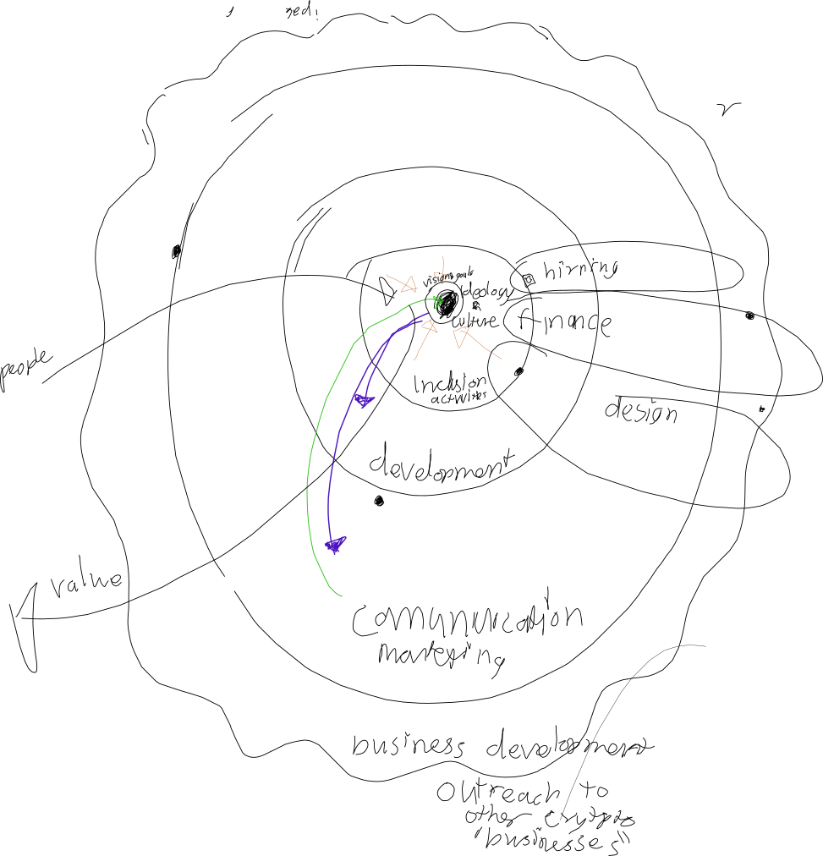

Core Organelles of Status
Status is organised into 5 main organelles and 5 supporting organelles. The outer two organelles (Marketing & Communications, Business Development) function primarily to interface with the greater social networks and pull people into the remaining three organelles, with a strong preference to pull directly into the two center organelles (Ideology & Culture, Inclusion Activities).

- Ideology & Culture
  - Vision & Goals
- Inclusion Activities
  - Hiring / Human Resources
- Development
- Marketing & Communications
- Business Development
- Finance
- Design
- Testing & Evaluation
- Research

Ideology & Culture
Both Grassroots Movements and Open Source projects heavily rely on a narrative cultural transmission and Status is no different. Thought Leadership, dissemination of values and meaning plays a core role in sustaining contributor involvement, boosting morale and making purpose. Though subtle the effects are felt throughout the organisation and help create cohesion.

Vision & Goals
Please see Goals of Organisation.

Inclusion Activities
Prevents encapsulation of organisation, creates onboarding ramps for people to participate Status at all levels, acts as screening filters and talent pool for Hiring.

Hiring / Human Resources
A function of Inclusion Activities, bootstraps the organisation contributors and is used directly if a hire needs to be made where no onboarding exists, when this happens it also shows a blindspot in our ability to grow the organisation organically.

Screens the market for talent. Contributes to building a reputation as topnotch employer. Takes care of team member onboarding, maintenance and departure activities. Administration of team agreement contracts. Completes payroll and related administration of registration with authorities, social security, employment permits, source tax, et cetera. Promotes teamwork and enhances the team spirit, as well as fosters satisfaction of the team members of being with Status. Resolves disputes and personal issues where employer involvement is appropriate or required. Works with Communications and Marketing to introduce the Ethereum community values to the team members.

Development
Provides all software development for organisational infrastructure, supports inclusion activities and builds base client.

Communications and Marketing
Involved in creating awareness of the organisation and product, with goals of user acquisition in both contributors and client users. Builds the brand name. Expands the reputation that the project is a flagship project within the Ethereum ecosystem. Ensures that the Ethereum ecosystem embraces the project, also by introducing the Ethereum community values to the project members.

Business Development
Focuses on connecting with other DApps, Blockchain and Enterprise Companies. Majority of B2B communications are handled here. Simplifies and automates the onboarding of new solutions onto the project platform and mobile/desktop appstore.

Finance
Supporting role of all other organelles. Limits the growth of the Status Core. Handles the M&A strategy. Manages money, accounts payables, and accounts receivables. Prepares budgets, monitors and approves expenses, maintains accounting and financial reporting. Completes tax matters. Oversees contract management, ensures regulatory and legal compliance while minimizing the team’s exposure to compliance matterse. Manages the corporate structure. Oversees relationships with external service providers which are not providing development services (consultants, auditors, regulators, other authorities, banks, landlords and others),

Design
Supporting role for Development & Marketing, dictates visual communication style. Provides unified templates to all project members and promotes their appropriate use.

Testing & Evaluation
Testing is easily understood in the context of software development, outside of this the Idea’s goals need to be evaluated for their merit to continue the implementation or force discussion on early disband & postmortem, should the Idea not be working for any reason, if there is disagreement in discussion, Idea is escalated to peers.

Research
Due to the decentralised nature of Status and the relatively recent field of crypto-economics and mechanism design, many of the things we’re trying to accomplish requires deep thought. Research is largely involved in thinking about how to build these systems, as well as find the best possible user experiences. Provides all project members as well as the Ethereum ecosystem an opportunity to contribute with ideas and promotes contributions. Addresses all submitted ideas and evaluates them for their value and follows up on their implementation.

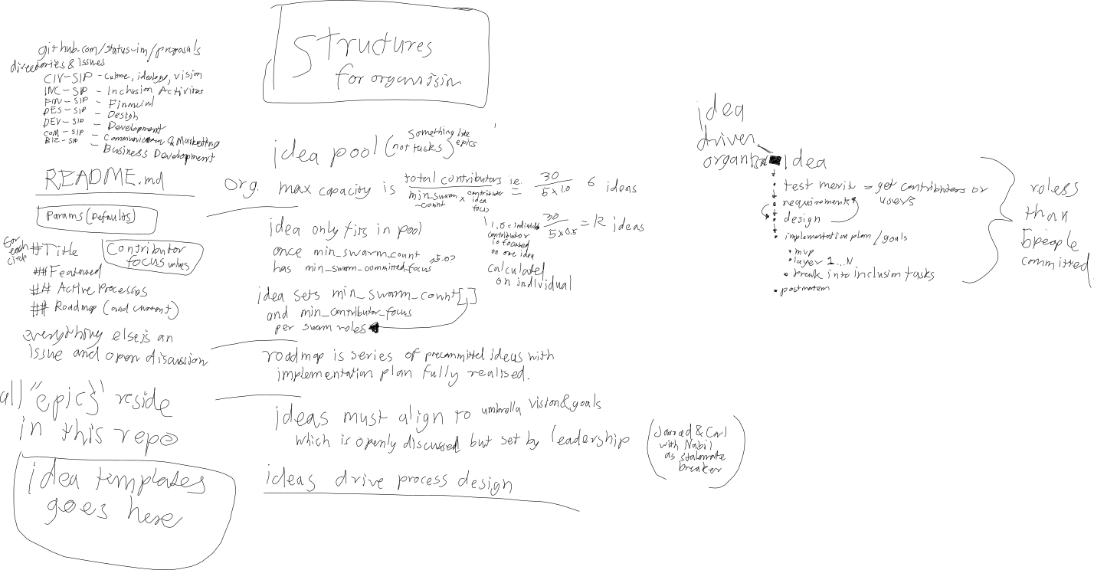

Idea Pool & README.md
https://github.com/status-im/ideas

The Idea Pool is a Github repository that contains a record of all Idea proposals in the form of open discussion Ideas as Issues and implemented ideas as markdown documents in their relevant directories.

This idea is adapted from Ethereum Improvement Proposals except the proposals themselves follow a more rigid process and are centered around organisational activities.

In its root directory it will contain a README.md which will define parameters that limit the organisations scope.

The organisational max capacity for work:

ORG_MAX_CAPACITY = TOTAL_CORE_CONTRIBUTORS / (MIN_SWARM_COUNT * CONTRIBUTOR_FOCUS)
ie. 30 / (5*1.0) = 6

Here we assume we have 30 core contributors, each Idea has a min team size of 5 and assumes each contributor is focused 100% on one Idea, allowing the organisation to have a maximum capacity to focus on 6 Ideas at a time, although in reality the focus is different per contributor and is dependent on how the Swarm is split over contributors in each organelle.

Contributor Focus:
Is currently not well defined, and open to suggestions I am currently assuming that a value of 1.0 means that the contributor is available 40 hours in a week. If it is at 0.5 then the contributor has pledged 20 hours a week, or half their focus, to 1 Idea already, or is only working 20 hours a week.

Each contributor will be listed in the README with their total focus, non-committed focus amount and committed focus including links to Ideas being worked on.

Minimum and Default Swarm Counts:

Any Idea proposal can set their SWARM_COUNT, but it must not below MIN_SWARM_COUNT, which I think should be 3. If the Idea does not define the SWARM_COUNT, then it defaults to 5.

Minimum and Default Swarm Focus:

Any Idea proposal can also set their SWARM_FOCUS, but it must not be below a MIN_SWARM_FOCUS, 3.0? if not specified it should use a default value, 5.0?

The README.md also provides a summarization of each Organelle and its relevant Ideas, for each organelle it can be structured like so.

# Title
## Featured
Is a list of any Ideas that should be highlighted for whatever reason, first
## Active Processes
Is a list of any implemented ideas, and their descriptions, should these Ideas implement a process for the organelle. This is necessary to communicate if an Idea updates/overrides a previous process.
## Roadmap
Lists the active Pull Requests of the Ideas as well as any future committed focus to Ideas to be implemented after.

Idea Proposals

The goal behind Idea Proposals is a unified process for making decentralised organisational changes within an organisational scope, it can also be used for the organisation’s subtasks.

While the below framework looks like a linear process, it is not. Potential swarm candidates are essentially staking their reputation and time on an idea and therefore they should have a vested interest in seeing the idea be actualised (using this framework as a reference) before committing to it 100%.

Swarm candidates then act as regulators of the minimal amount of effective planning and bureaucracy.

It is currently is specified as:

- Idea Vision (Proposal & Test Merit)
Initial draft of proposal is submitted as a Github issue, this can be a general summary but needs to be enticing enough to attract other contributors, therefore the proposer should fill out the template (subsequent sections) of proposal to the best of their ability. The idea is now up for discussion.

Each Idea gets an Idea code from the Organelle it applies to followed by its Github Issue number. i.e, CIV#100, INC#100, FIN#100, DES#100, DEV#100, COM#100, BIZ#100.

It is then up to the proposer to test to merit of the idea with other contributors, the idea must reach a MIN_CONTRIBUTOR value and MIN_FOCUS value, for the idea to proceed. Contributors should assess the Idea based on its merit and alignment with overall vision.

Together the contributors form a Swarm which is a sum of individual contributor FOCUS commitment to the fruition of the idea. This means fully fleshed out Requirements, Design, Goals & Implementation Plan, and handle a Post-Mortem.

- Define Roles (Swarm Participants / Committed Contributors)
  - Lead Contributor
  - Testing & Evaluation
  - Contributor x 2 (Minimum)

Each contributor pledges to the idea with their FOCUS value.

Here all roles in swarm are defined and filled, one of the contributors should responsibility of the Idea as Lead.

Testing support role is also mandatory to check in on specified Goal dates or earlier. Testing at this time will force a discussion at set goal dates to continue implementation or recommend disband and post-mortem.

- Requirements
The Swarm must then develop a fully fleshed out Requirements document for the idea to proceed, there is no approval unless the idea requires to be reviewed by supporting organelles (Financial, Hiring or Design).

- Goals & Implementation Plan
  - Inclusion Rituals
  - Minimal Viable Product
  - Iteration 1...N

Here the Swarm must specify the goals and completion dates. Every idea must include some form of open participation built into it, this is to ensure that Status as an organisation remains open and actively prevents encapsulation / ‘inner circle’ development.

The other mandatory goal is the MVP, this must absolutely be the fastest, ‘hackiest’ way to have the idea productive.

After this there can be N layers that improve the overall idea until it is fully realised.

Everyone in Swarm must have a crystal-clear understanding of the next steps. It should be easy for anyone external to the Swarm to read, understand and participate in. There should be no Bus Factor.

Testing supporting role will check in on dates and can force a discussion to disband and do post mortem. If there is a disagreement, it can be escalated to people outside Swarm to decide to continue or not.

- Supporting Role / Organelle Communication
Once Requirements and Goals are fleshed out, then it should be communicated to supporting organelles.

If it will cost additional funds over $100, excluding development costs, it should be reviewed and approved by Financial supporting organelle.

If the Idea requires visual communication, then Design supporting organelle will be involved here. Design should fully understand and contribute to the Idea.

If the Idea requires a new hire, Hiring supporting organelle must be involved and approve.

Once done the a Pull Request referencing the Idea is created and is used to manage the Idea.

Testing agrees to check in on dates and/or be available beforehand.

- Post-Mortem
Before the Swarm can disband from the Idea and reclaim individual FOCUS value, they must first document how the Idea was executed, what went well, what didn’t go well.

An idea is abandoned if all goals successfully met, if the SWARM_COUNT drops below MIN_CONTRIBUTOR or sum FOCUS drops below MIN_FOCUS count.

